Nome: Raul Tomaz

Turma: 1DS

Netuno & Sereias

Programação e Algoritmos

Prof. Saiz

Agosto de 2024

# CÓDIGO

**using** System;  
**using** System.Collections.Generic;  
**using** System.Drawing;  
**using** System.Windows.Forms;  
  
**namespace** Atividade_7__para_entregar_  
{  
  
    **public** partial class MainForm : Form  
    {  
        **public** MainForm()  
        {  
  
            **InitializeComponent**();  
            // volume = altura * largura * comprimento  
  
        }  
        void **Button1Click**(object sender, EventArgs e)  
        {  
            **int** h, l, c;  
            **float** vl, sv;  
              
            h = **int**.**Parse** (*textBox1*.Text);  
            l = **int**.**Parse** (*textBox2*.Text);  
            c = **int**.**Parse** (*textBox3*.Text);  
            vl = h * l * c;  
            sv = 49.99f * vl + 250.00f;  
            *label8*.Text = vl.**ToString**();  
            *textBox4*.Text = sv.**ToString**("C");  
        }  
    }  
}

# PRINTS

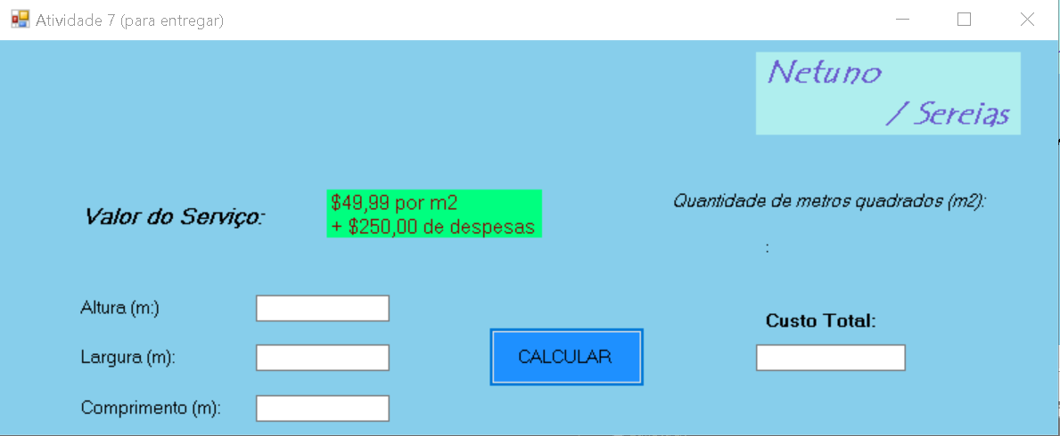

Figura – Layout

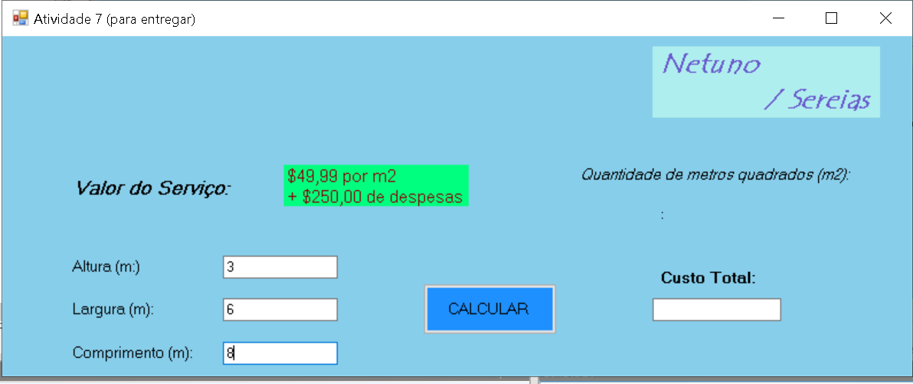

Figura - Teste 1

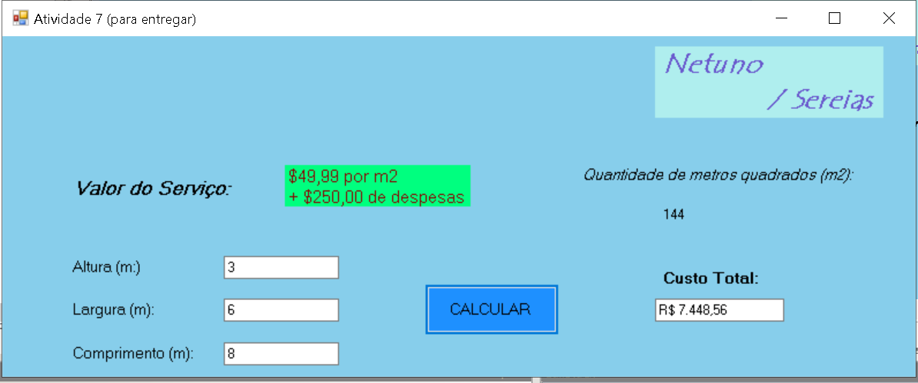

Figura - Teste 1

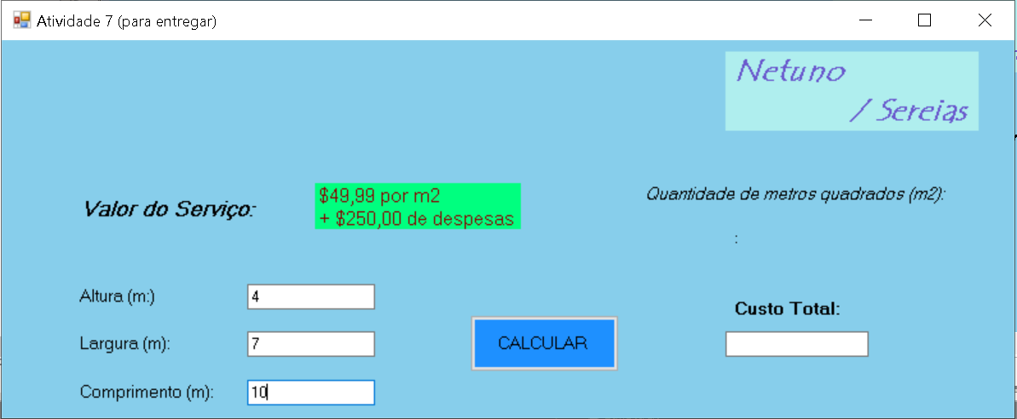

Figura - Teste 2

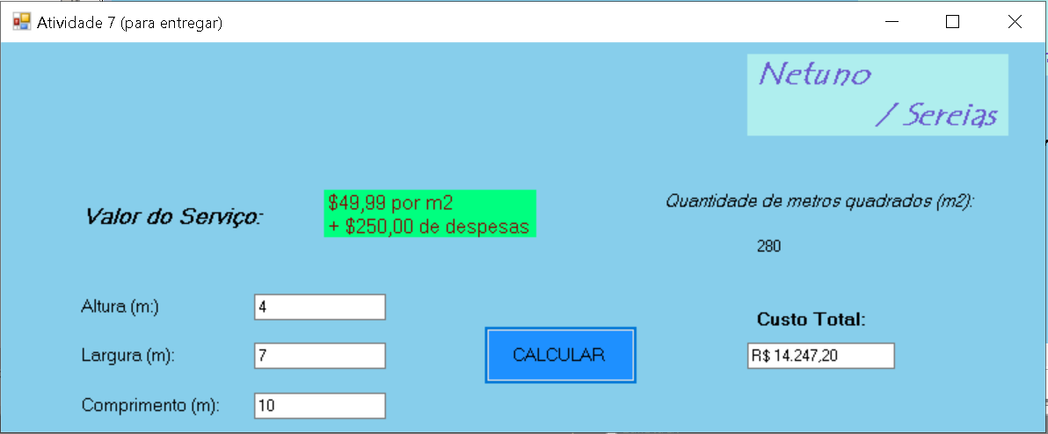

Figura - Teste 2